**File Management Assignment**

1. Downloads folder showing the course outline pdf

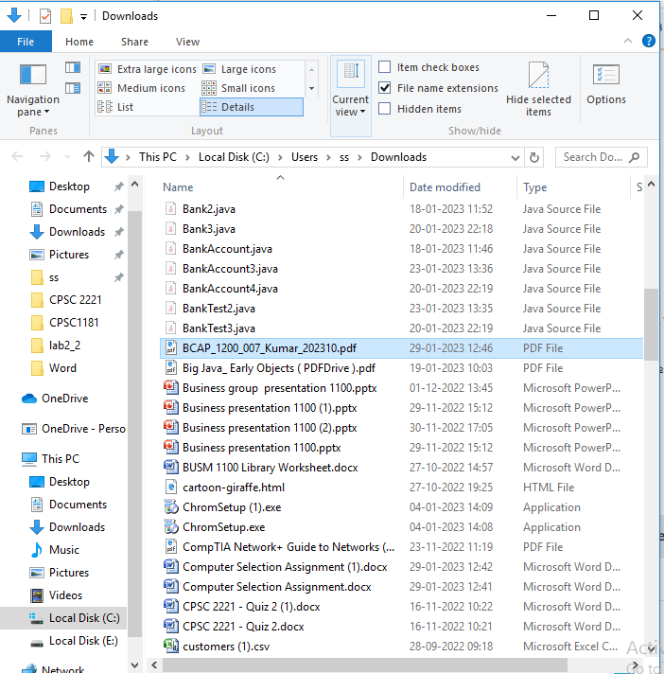

1. BCAP 1200 Folder and its sub-folders.

1. File explorer window showing BCAP 1200 and other course folders.

1. MISC Folder and the course outline file.

1. BCAP1200 Folder pinned to quick access bar.

